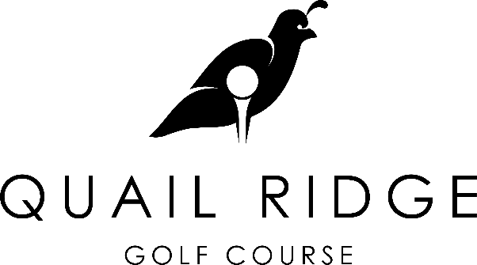

4-Man 2-Best Ball
Saturday and Sunday, April 30th – May 1st, 2022
$200 Entry fee per team
No maximum handicap spread. 75% individual handicap Gross and Net payout
Tee times starting at 8:30am both days
Call 541-523-2358 for tee times _____________________________________________________________________________________
ENTRY FORM
Name_____________________________________________GHIN#_______________HDCP INDEX____________ Address______________________________________ City____________ Zip____________Phone__________________ Email__________________________________
Name_____________________________________________GHIN#_______________HDCP INDEX____________ Address______________________________________ City____________ Zip____________Phone__________________ Email__________________________________
Name_____________________________________________GHIN#_______________HDCP INDEX____________ Address______________________________________ City____________ Zip____________Phone__________________ Email__________________________________
Name_____________________________________________GHIN#_______________HDCP INDEX____________ Address______________________________________ City____________ Zip____________Phone__________________ Email__________________________________
Preferred tee times (circle one for each day)
Saturday before 10:00am | Saturday after 10:00am
Sunday before 10:00am | Sunday after 10:00am
Send entry forms to:
Quail Ridge Golf Course
2801 Indiana Ave. Baker City, OR 9781

