10th ANNUAL
BAKER BENEFIT BASH TOURNAMENT
3 PERSON SCRAMBLE
36 Holes of Golf
June 4th – 5th 2022

Entry Fee: $255 per team (Includes closest to Pin on Par 3s, both days)
Includes Saturday evening steak dinner (additional meal $15)
Handicaps: Target team total of 42 CH per team. Higher or lower will be adjusted.

Schedule of events:
12:00 Shotgun Saturday, June 4th
6:00 BBQ Dinner Saturday evening (additional tickets $15) Calcutta
following dinner Saturday evening and auction.
9:00 Shotgun on Sunday, June 5th

**ALL PROCEEDS GO TO COURSE IMPROVEMENTS. We need your continued support to keep improving our course.
**ALL PRIZES WILL BE PAID IN CASH!!

Registration:
Player 1:_______________________________HCP_______USGA #__________
Player 2:_______________________________HCP_______USGA #__________
Player 3:_______________________________HCP_______USGA #__________

Quail Ridge Golf Course
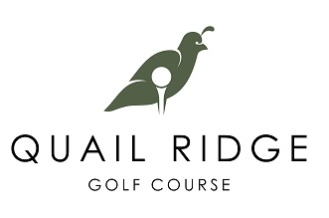
2801 Indiana Ave., Baker City, OR 97814
541-523-2358 quailridgebakercity.com

